**Lab2 – Creating Virtual Machine – Ubuntu in Azure**

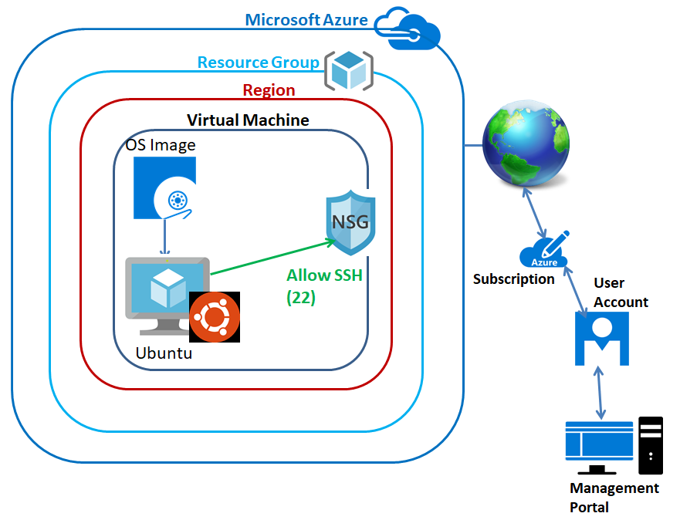

**In Dashboard, Click “Resource groups”.**

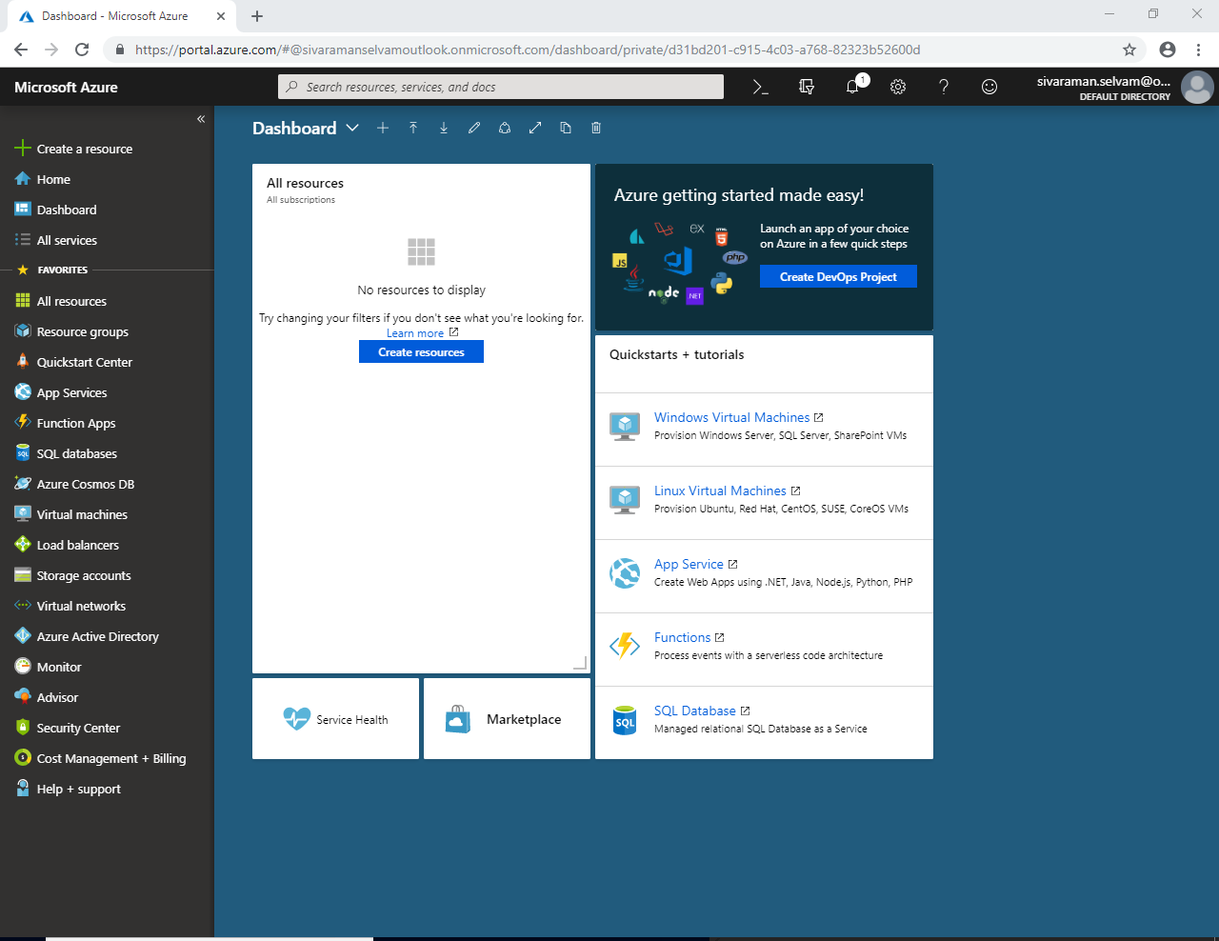

**In “Resource Groups” click “Add”.**

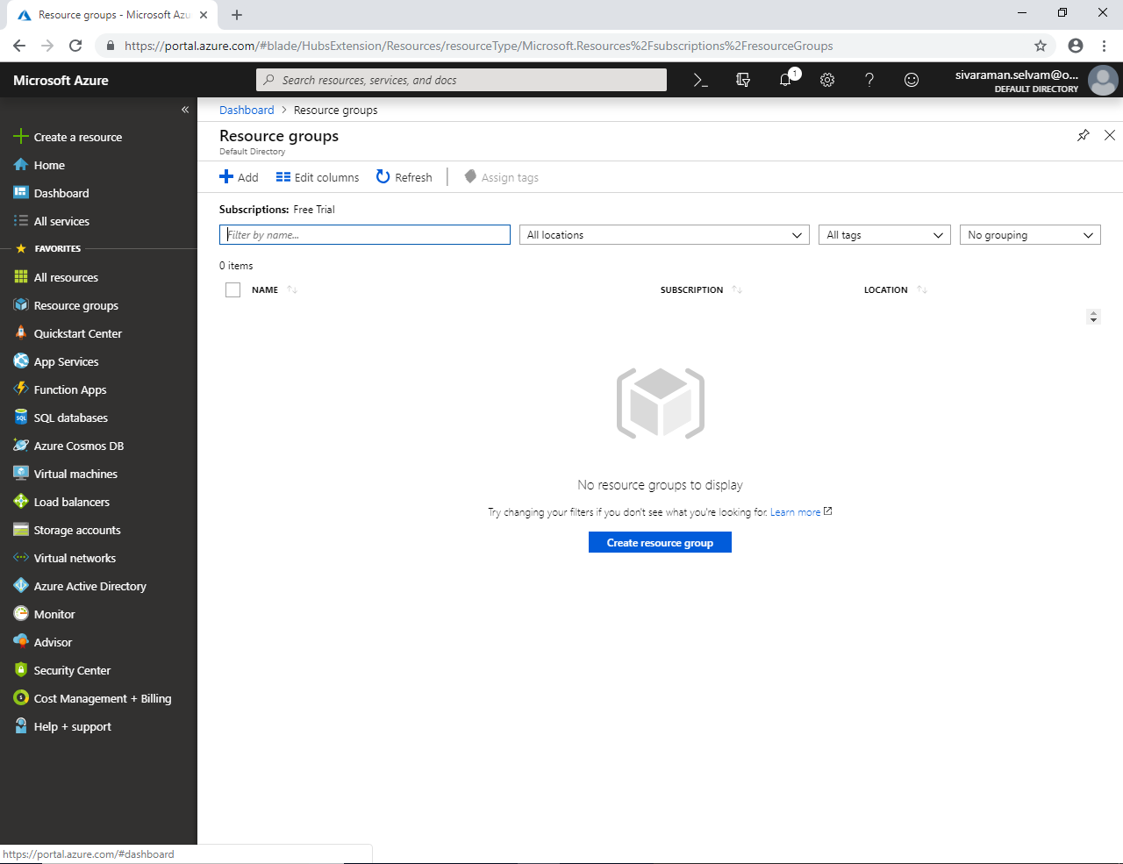

**Type “Resource Group” as “SansboundAzureClass”.**

**Subscription should be “Free Trial”**

**Region I will select “South India”.**

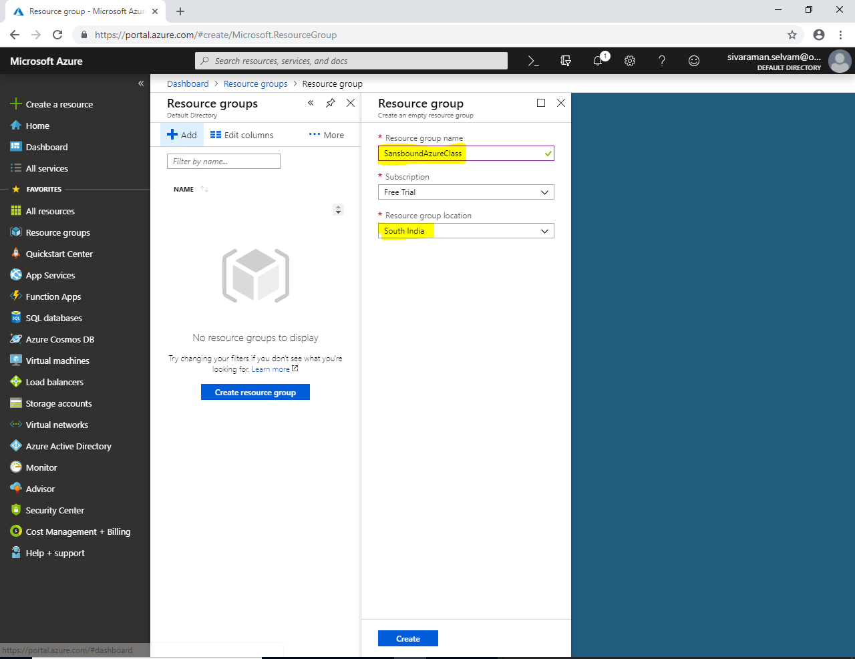

**Click “Create”**.

**In “Resource Groups” click “Refresh” to view the newly created “Resource Groups”.**

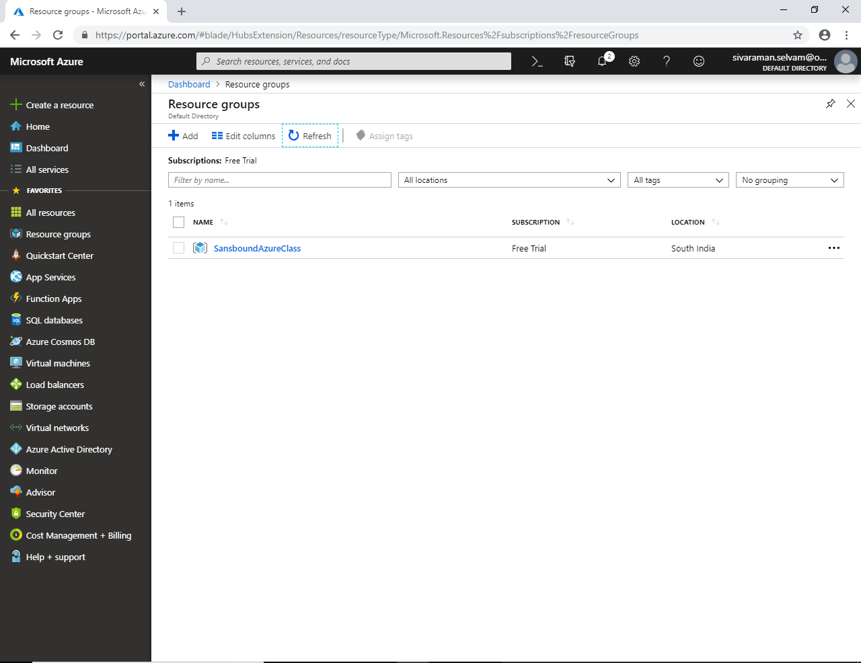

**In Dashboard, click “Virtual machines”**

**Click “Add”.**

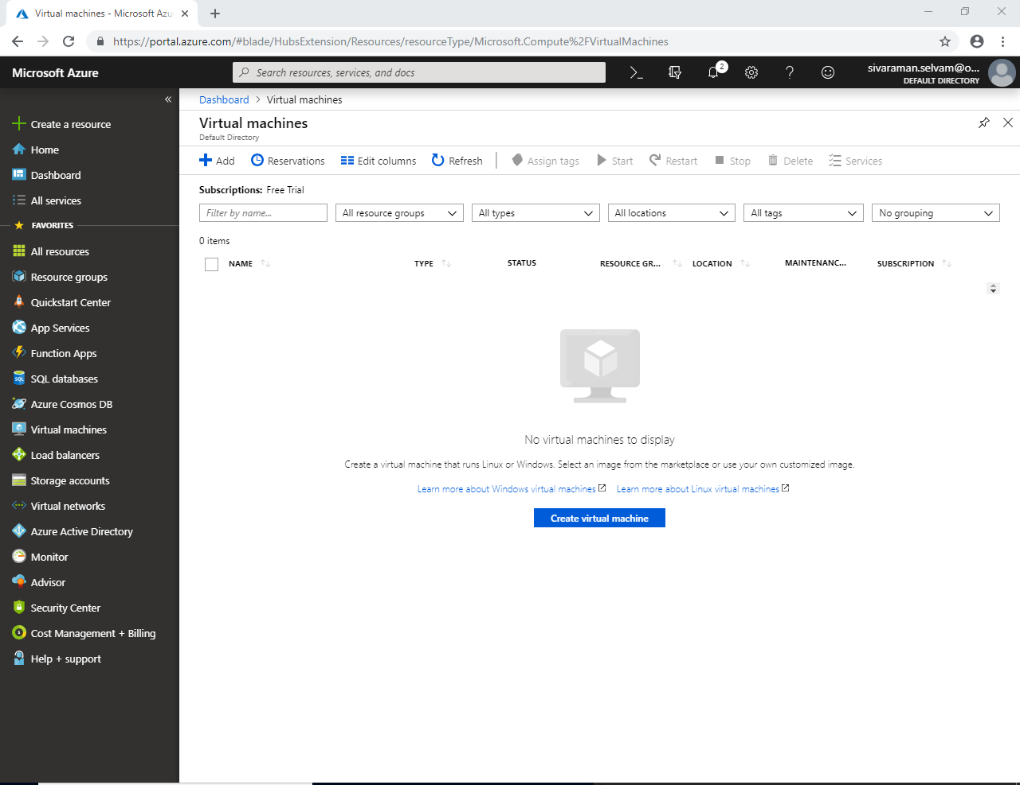

**While creating Virtual machine, Select the Subscription “Free Trial” and select the “Resource Group” as “SansboundAzureClass”.**

**Type virtual machine name as “Ubuntu-VM” and select the Region as “South India”.**

**Select OS Image as “Ubuntu Server 18.04 LTS”.**

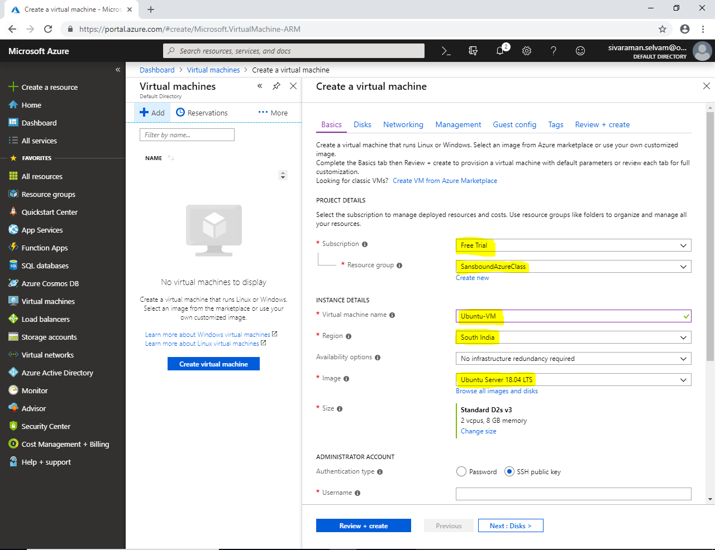

**In Virtual machine size by default it has been selected “Standard D2s v3” with 2 vCPU’s and 8 GB RAM.**

**Click “Change size” But, we need to change it to as Standard “B1s” manually.**

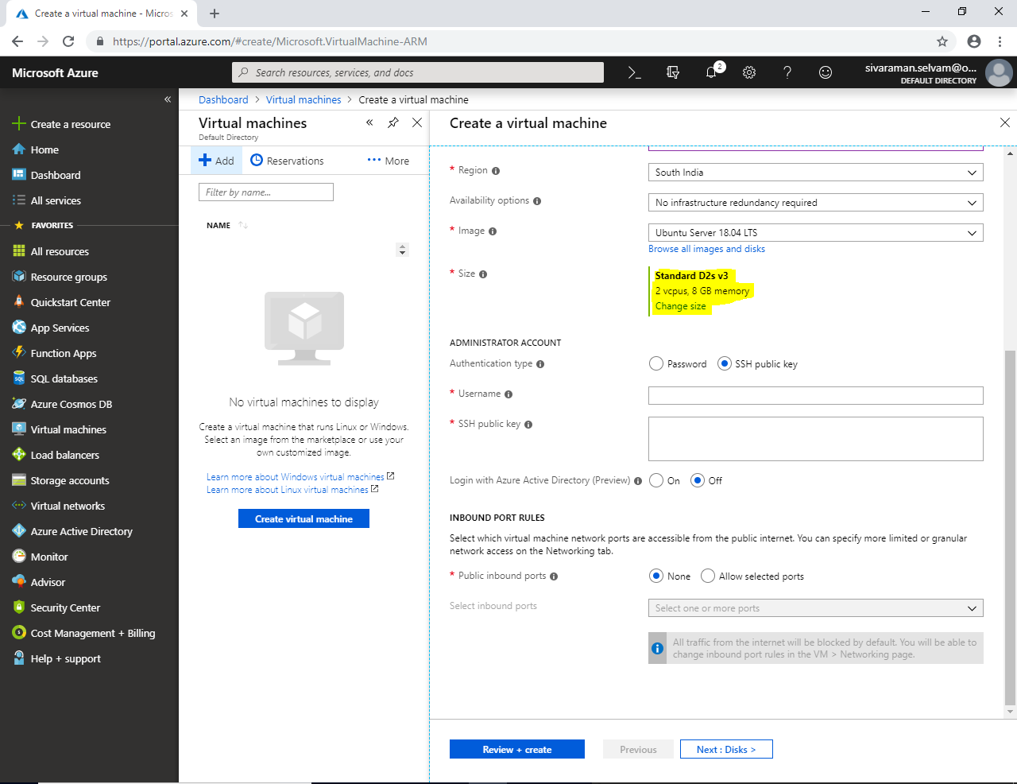

**Select Virtual machine size as Standard “B1s” and click “Select” button at bottom of the portal.**

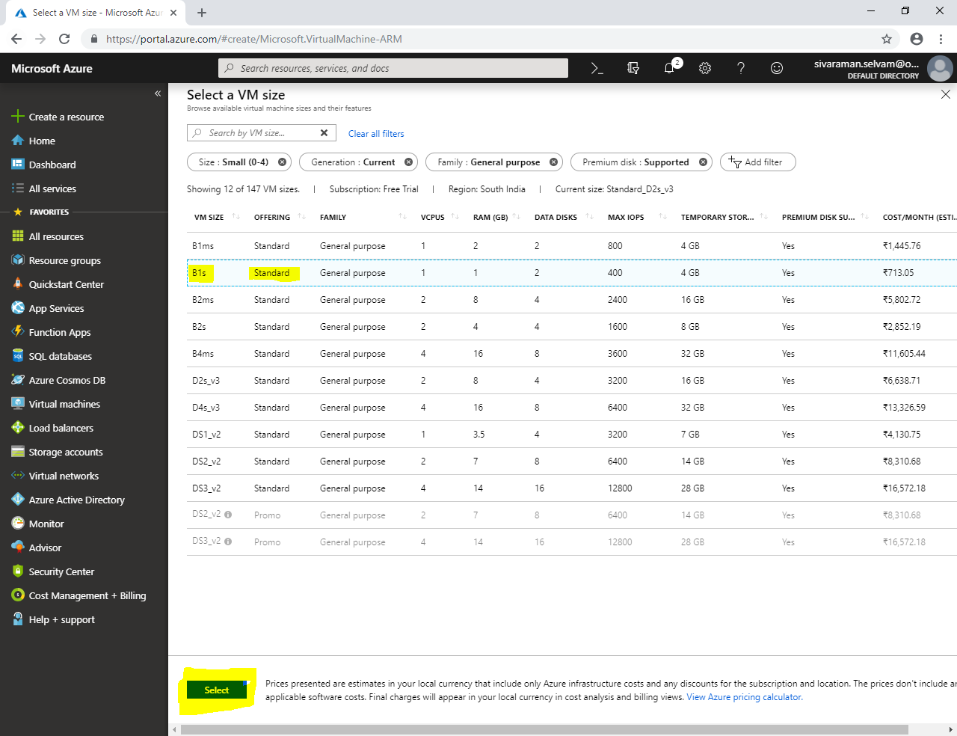

**Ensure that VM Size is “Standard B1s” is selected.**

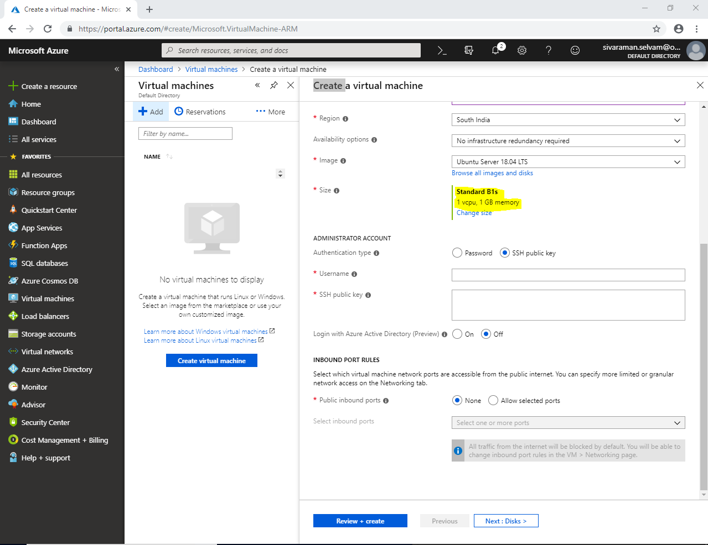

**In “Administrator Account” click the option “Password” and type username to access the virtual machine remotely.**

**Set “Password” with 12 characters to access the server remotely.**

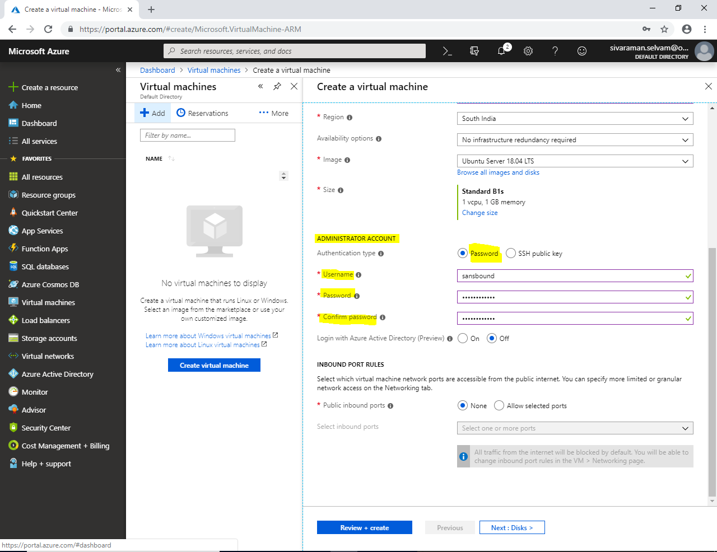

**In “Inbound Port Rules” by default it has been set as none.**

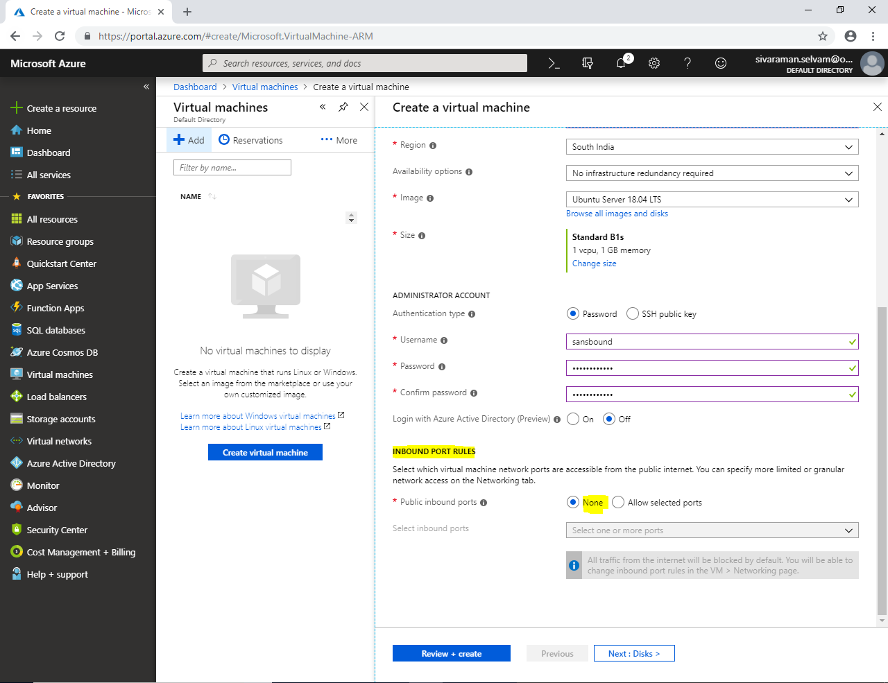

**In “Inbound Port Rules” click “Allow selected ports”.**

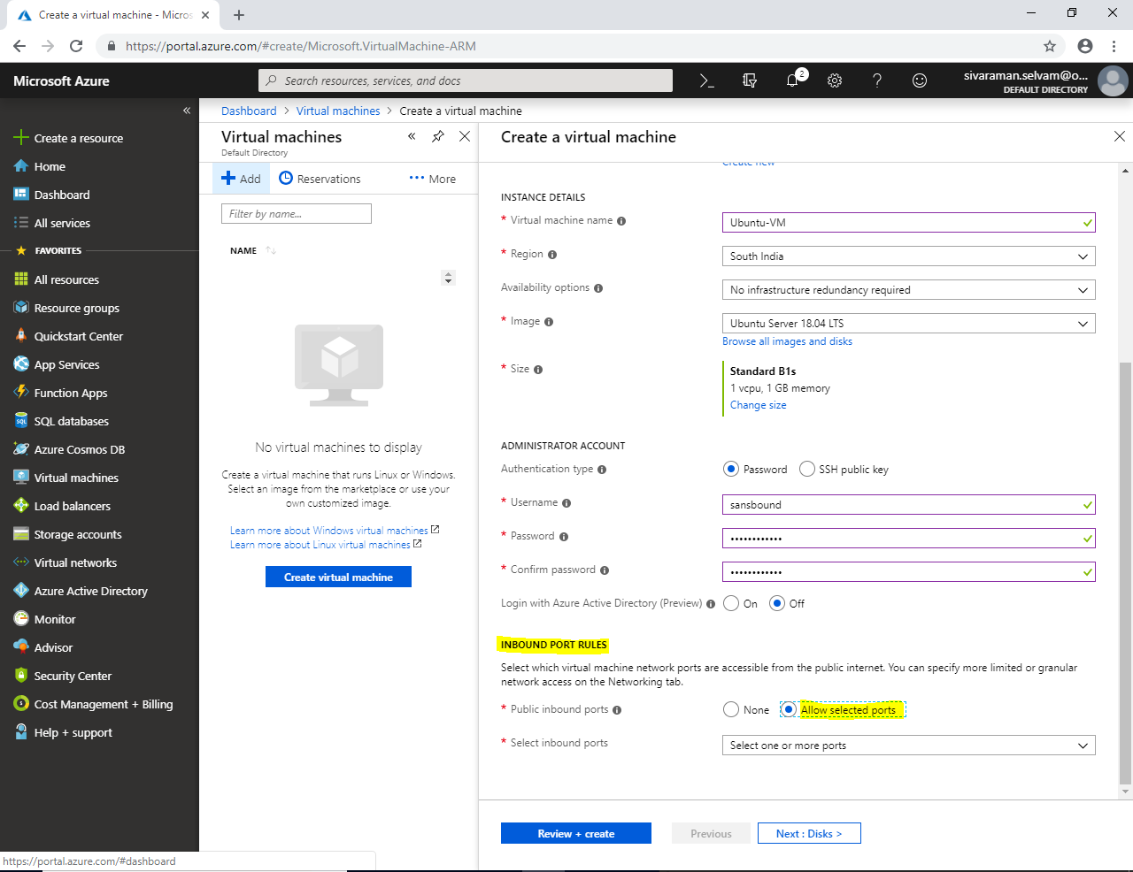

**Click “Select One or more ports”.**

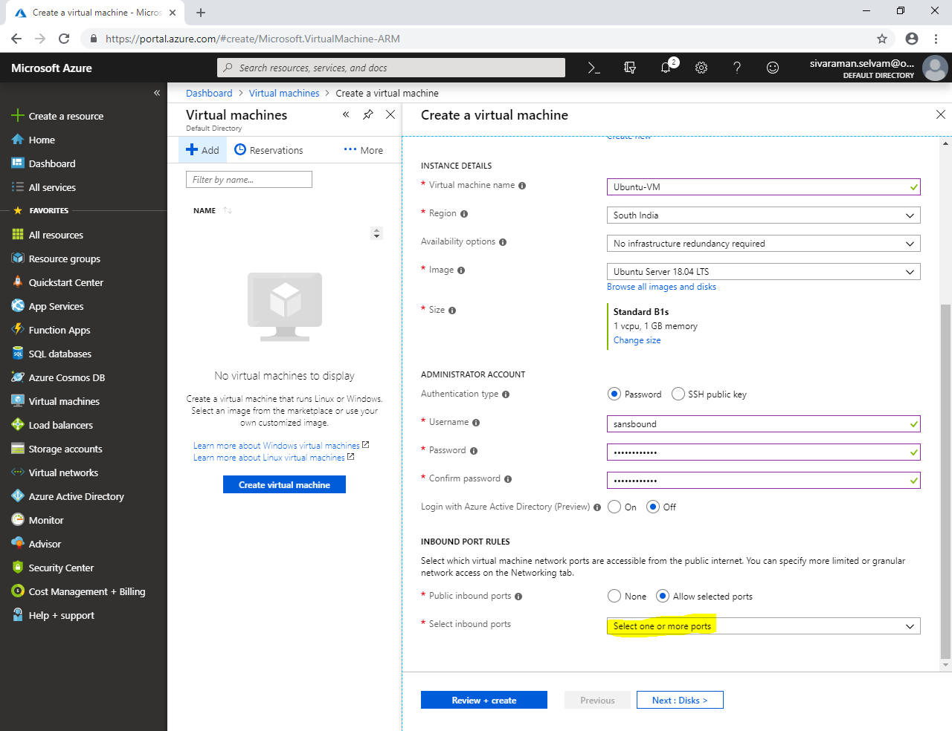

**In “Selected Inbound Ports” drop down list, select “SSH (22)”.**

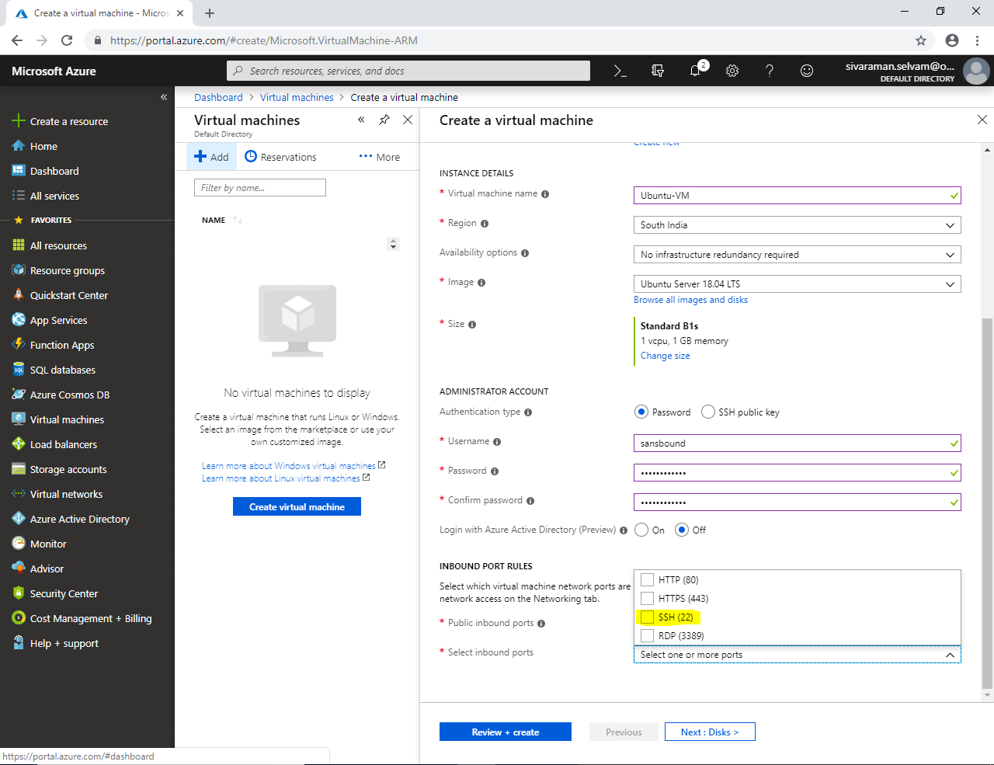

**Click “Review and Create”.**

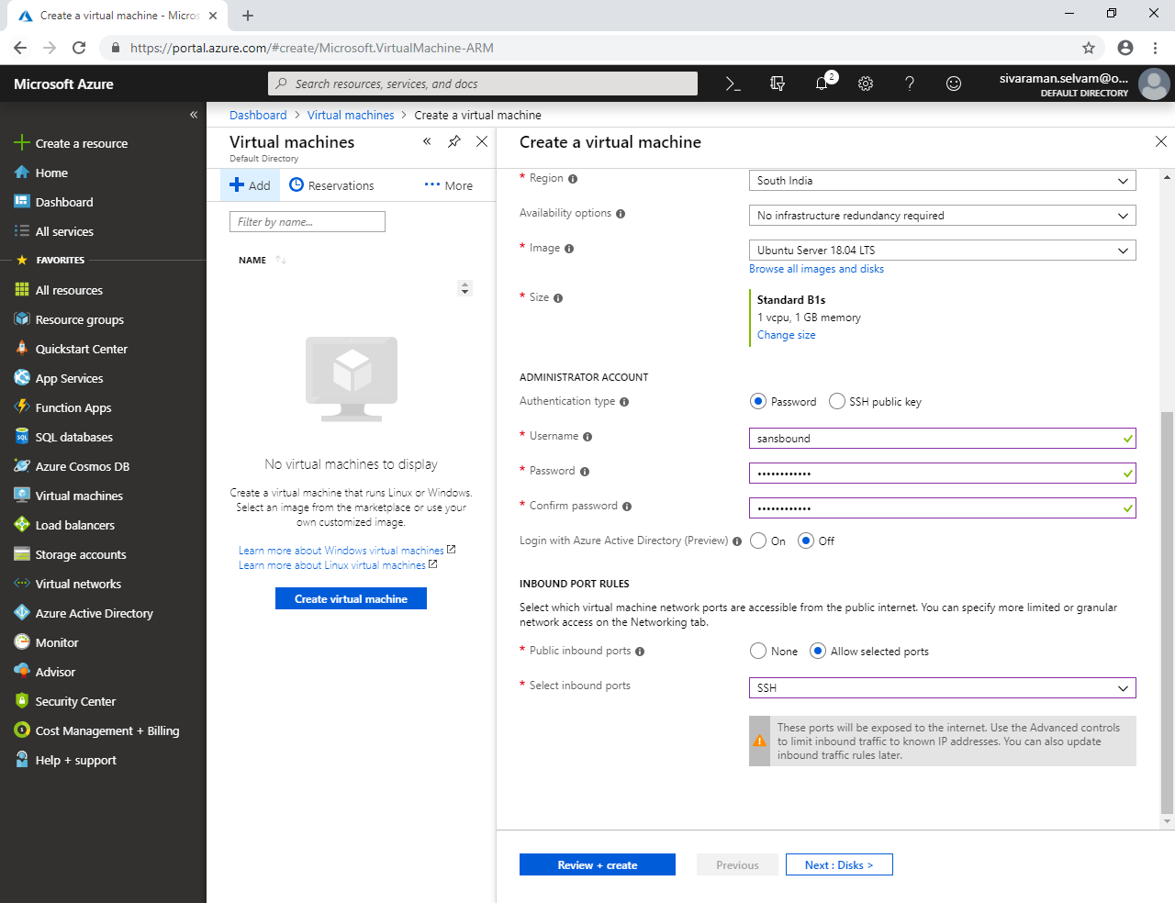

**Click “Create” to create Virtual machine.**

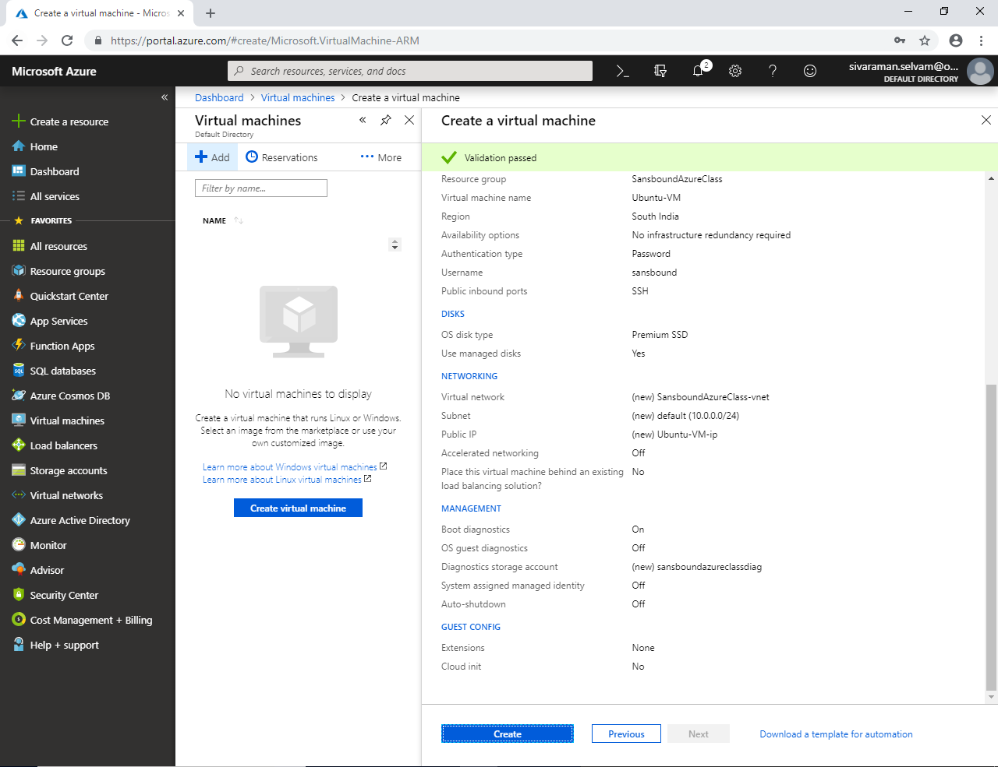

**Ubuntu VM has been deployed successfully.**

**Click “Ubuntu-VM”**

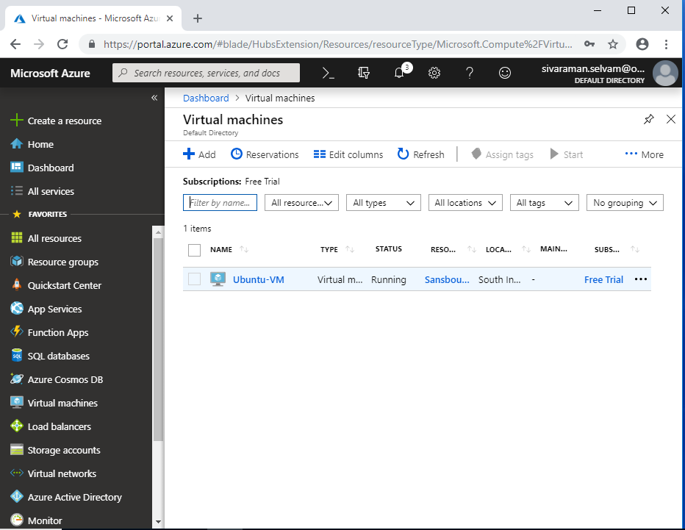

**In Ubuntu-VM you have got the public IP address as 104.211.222.73**

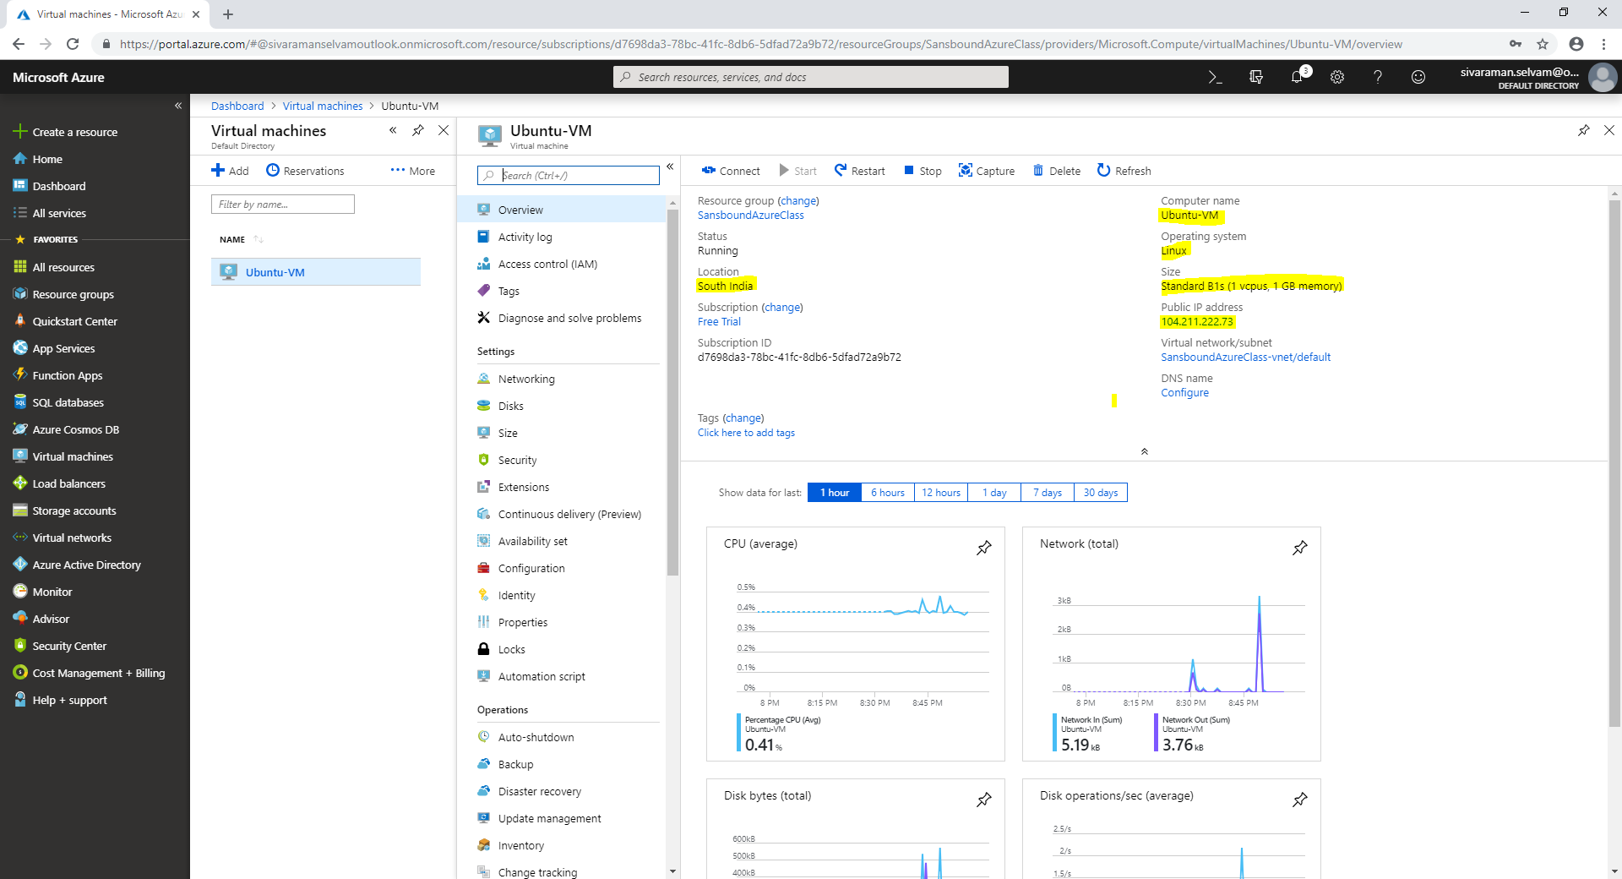

**We have required to access the Ubuntu server by using putty.exe.**

**If you have putty, please launch the exe otherwise download it from internet.**

**Type the IP of Ubuntu server and Click “Open” to access the server through SSH.**

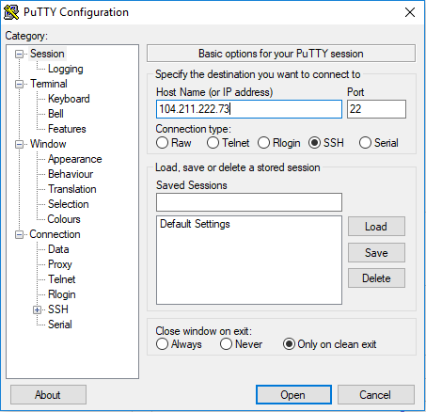

**Click “Yes”.**

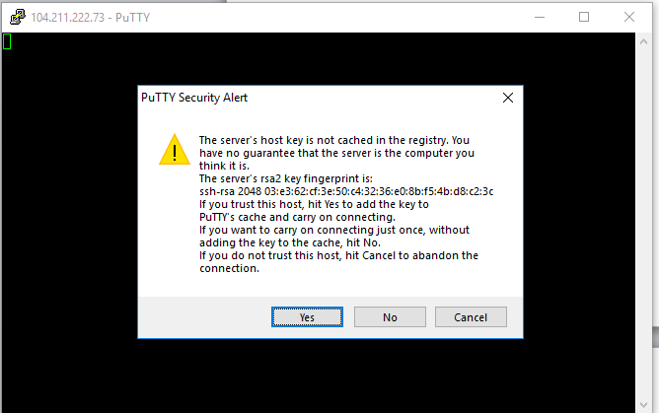

**Type Username as “sansbound” and press “Enter”.**

**Type password of “Ubuntu Server” and press “Enter”.**

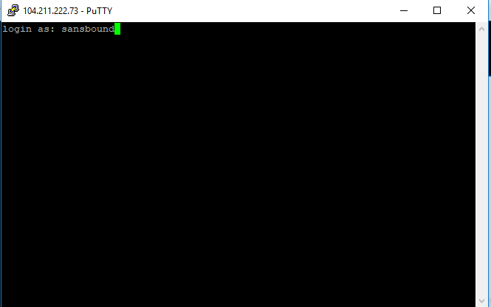

**Now you have successfully logged into the Ubuntu Server.**

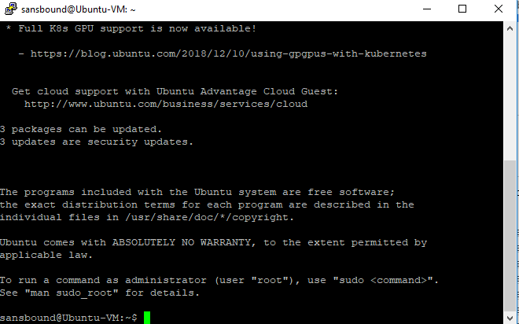

**Type sudo –i and press “Enter” to login as root account.**

**You are able to see that Ubuntu has been logged in with root account.**

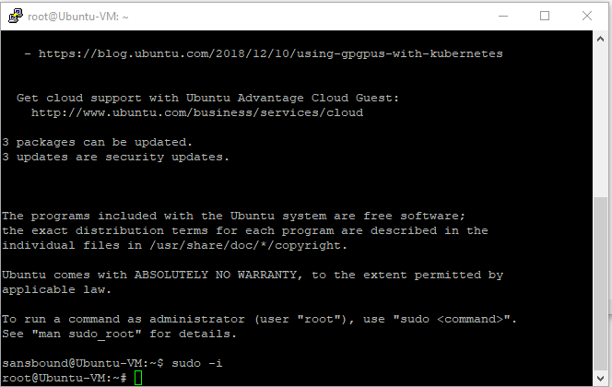

**Note : Now you can stop the virtual machine and delete the Resource groups in Free trial / learning purpose only. Please do not delete the Resource group in Realtime environment.**